**Evidence Bug #01**

|  |  |  |  |  |  |
| --- | --- | --- | --- | --- | --- |
| **Bug** | **Description** | **Possible solution** | **Evidence** | **Status** | **Priority** |
| #01 - Invalid birthday date (year) field | The birthday date field is allowing you to put a year above the current year (example 2030). | Validate that the entered year is valid, compared to the current year and a message should be displayed, about the invalid year and request that it be inserted again. | Bug01.docx | Open | 3 |

Form:

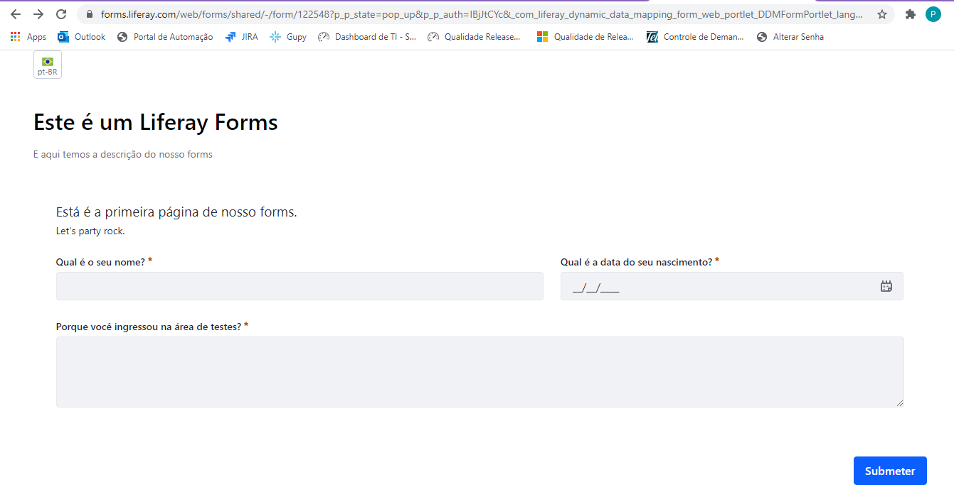

Form filled with invalid year:

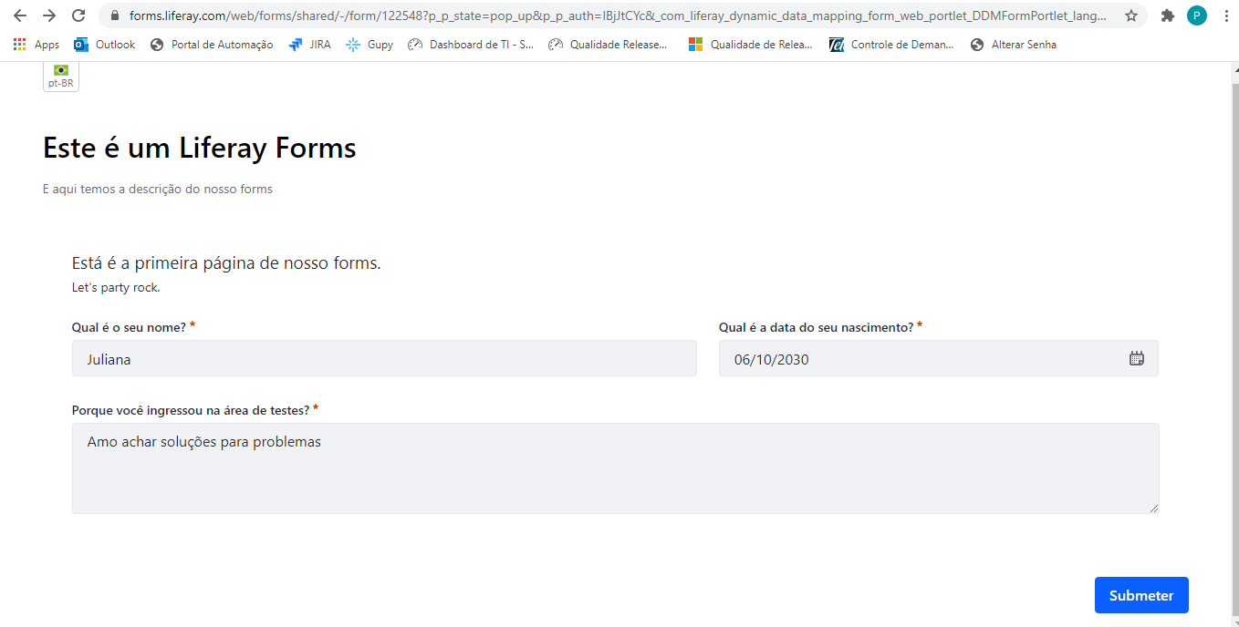

Form successfully submitted:

